**Software Testing Life cycle (STLC)**

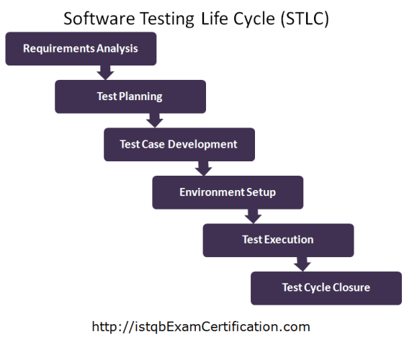

The Software Testing Life Cycle (STLC) is a series of sequential phases or activities that define the testing process for software development projects. STLC outlines the steps to be followed to ensure that the software meets quality standards, functional requirements, and user expectations. While specific methodologies may vary, the core phases of the STLC typically include:

1. **Requirement Analysis**:
   * In this phase, the testing team thoroughly reviews and analyzes the software requirements documentation to understand the expected behavior, features, and functionalities of the software.
   * Testers identify testable requirements, prioritize them, and create a traceability matrix to map test cases to specific requirements.
2. **Test Planning**:
   * Test planning involves defining the overall testing strategy, objectives, scope, timelines, and resources required for testing.
   * Test planning also includes identifying test environments, tools, and techniques to be used, as well as defining roles and responsibilities within the testing team.
3. **Test Case Development**:
   * In this phase, test cases are designed based on the requirements and test scenarios identified during requirement analysis.
   * Test cases outline the steps to be followed, expected outcomes, and test data required to verify the functionality of the software.
4. **Test Environment Setup**:
   * Test environment setup involves configuring the necessary hardware, software, and network infrastructure required for testing.
   * Test environments should mirror the production environment as closely as possible to ensure accurate testing results.
5. **Test Execution**:
   * Test execution is the phase where test cases are executed based on the test plan and test schedule.
   * Testers execute both manual and automated test cases, record test results, and report defects found during testing.
6. **Defect Tracking and Management**:
   * Defect tracking and management involve logging, prioritizing, and tracking defects identified during testing.
   * Defects are assigned to appropriate team members for resolution, and their status is tracked until they are fixed and verified.
7. **Test Reporting**:
   * Test reporting involves summarizing testing activities, results, and metrics in comprehensive test reports.
   * Test reports provide stakeholders with insights into the quality of the software, including the number of defects found, test coverage, and overall test progress.
8. **Test Closure**:
   * Test closure marks the end of the testing process for a particular software release or project.
   * Test closure activities include analyzing test results, conducting a final review of testing activities, archiving test artifacts, and preparing lessons learned for future projects.

It's important to note that the STLC is iterative and may involve multiple cycles of testing as the software evolves and new requirements emerge. Additionally, the STLC may be adapted or customized based on the specific needs, methodologies, and constraints of the project or organization.